Faith presbyterian church
July 12, 2020
THE PARABLE OF THE SOWER
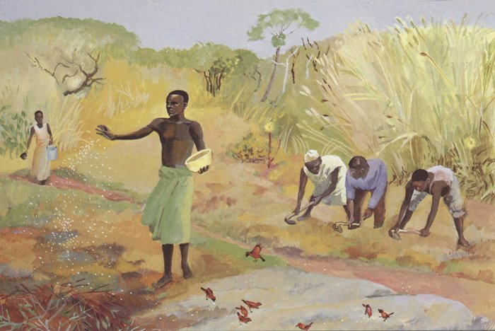
Artist: Jesus Mafu The Cameroon 1973

IN HOME WORSHIP GUIDE
FAITH PRESBTERIAN CHURCH
July 12, 2020
Prelude:
Call to Worship: Psalm 119: 105
Leader: Your word is a lamp to my feet,
People: And a light to my path.
Leader: Accept my offering of praise, O Lord,
People: And Teach me your ordinances!
The Doxology
Old Testament Reading: Isaiah 55:10-13

Gospel Reading: Matthew 13:1-9,18-23
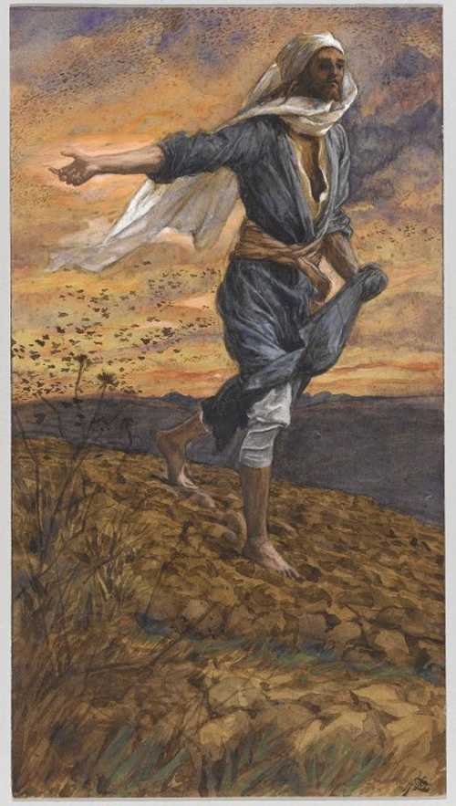
Message: THE PARABLE OF THE SOWER Dr. Roger Verse
Note how indiscriminately the sower sows his seeds.

I
The Parable of the Sower is second in familiarity to the Parable of the Prodigal Son.
In the Gospels, Jesus spoke more than 40 parables, some quite short, others rather long. C. S Dodd, a Biblical Scholar, commented that Jesus told parables “to tease the mind into active thought.”
Tease the mind to active thought. The parable of the Sower certainly does that!
This is one of Jesus’ parables about the Kingdom of God. Frequently parables would begin by Jesus saying, “the kingdom of God is like….” Jesus is describing for his listeners what characterizes the life experience of those who live in community with him, the Father, and the Holy Spirit. It is a kingdom that is characterized by God’s reign in the life of believers. Simplified, “the community of Jesus’ followers is like…
We are part of that community… The Kingdom of God
II
This parable has one character, the sower. His activity is to sow seeds. The seeds fall on four kinds of soil: hardened, shallow, thorny, and good. On the path, birds eat them up; seeds on rocky ground never get a chance root securely and die out; others fall among thorns and the thorns choke the life out of them. Still others fall on good soil. The parable ends with Jesus describing an abundant crop!
The meaning: Some people hear the word and the evil one immediately snatches it away. Others hear the word and it never really takes root. The thorns, Jesus says, are the cares of the world and the lure of wealth that choke the life out of them. But for those sown in good soil, they are the ones who hear the word and understand it.
This parable Jesus spoke to his disciples to specifically prepare them for the new reality they would face as they sought to spread the good word - the gospel message. They, the disciples, are to be gospel sowers who keep on sowing regardless of all the circumstances inhospitable to the harvest.
III
So, let’s think about the way this parable might “tease the mind into active thought.”
What kind of sower of seeds sows them on a hardened path or among thorns. Or, what kind of farmer does not prepare, till, or work the soil before the sowing the seeds. Not a very good investment of your “seed resources” is it?
The sower seems oblivious to where the seed fall. Is the sower wasting their time, energy, and money by not proper planning and targeting the best spot to plant the seeds?
What do you make of this sower who so freely and indiscriminately throws the seeds?
What’s the point, Jesus?
IV
I would suggest that Jesus is teaching his disciples two things.
First and most importantly, your commission or task as my disciples is just to sow the gospel message. I am sure you have heard the phrase, “let the chips fall where they may.” Jesus may just be telling his disciples to let the “seeds fall where they may.” The disciples’ mission, and ours is to get the word out independent of place or nature of the soil. Just scatter the seeds abundantly and joyfully. The result is up to recipient and the Spirit of the living God.
And second, Jesus is telling his disciples to be realistic as to the reception, acceptance, and sustainability of the message sown. Not every seed you sow will bear fruit. But don’t give up! There will be an abundant harvest.
Take a read of Mathew 13: 31. ³¹ Jesus put before them another parable: “The kingdom of heaven is like a mustard seed that someone took and sowed in his field; ³² it is the smallest of all the seeds, but when it has grown it is the greatest of shrubs and becomes a tree, so that the birds of the air come and make nests in its branches.”
One never knows the potential of any one seed that may have been so indiscriminately thrown into the air!
Unison Prayer:
O God of mercy, in Jesus Christ you freed us from sin and death, and by your Holy Spirit you nourish our mortal bodies with life. As the Ancient Gardner that you are, plant us now in good soil that our lives may flower in righteousness and peace. Grant that through your Holy Spirit we may bear fruit abundantly in the service of our Lord Jesus Christ. Amen!
Hymn: Pass It On
It only takes a spark to get a fire going,
And soon all those around can warm up in its glowing;
That’s how it is with God’s Love,
Once you’ve experienced it,
Your spread the love to everyone
You want to pass it on.
What a wonderous time is spring,
When all the tress are budding
The birds begin to sing, the flowers start their blooming;
That’s how it is with God’s love,
Once you’ve experienced it.
You want to sing, it’s fresh like spring,
You want to pass it on.
I wish for you my friend
This happiness that I’ve found;
You can depend on God
It matters not where you’re bound,
I’ll shout it from the mountain top
I want the world to know
The Lord of love has come to me
I want to pass it on.
Prayers of the People and Lord’s Prayer:

The Charge to the Congregation and Benediction:

A Little Christmas in July: “Go Tell It on the Mountain”

While shepherds kept there watching
O’r silent flocks by night
Behold throughout the heavens
There shown a holy light

Go tell it on the mountain
Over the hills and everywhere
Go tell it on the mountain
That Jesus Christ is born

The shepherds feared and trembled
When low above the earth
Rang out the angel chorus
That hailed the Savior's birth

Go tell it on the mountain
Over the hills and everywhere
Go tell it on the mountain
That Jesus Christ is born

Down in a lowly manger
The humble Christ was born
And God send us salvation
That blessed Christmas morn

Go, tell it on the mountain
Over the hills and everywhere
Go, tell it on the mountain
That Jesus Christ is born

