FAITH PRESBYTERIAN CHURCH
SUNDAY, JUNE 28, 2020

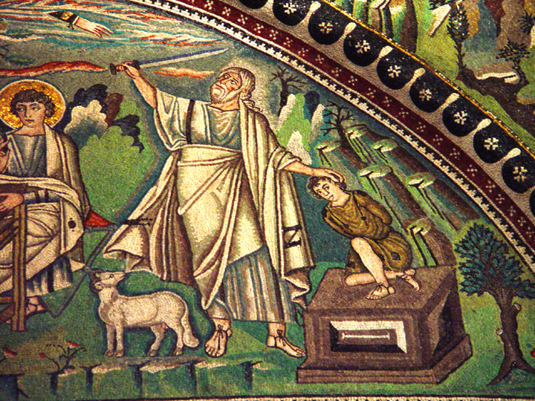

The Sacrifice of Isaac

THE LORD WILL PROVIDE
Preludes:

Call to Worship Psalm 89:1-4, 15
Leader: I will sing of your steadfast love, O LORD, forever;
People: With my mouth I will proclaim your faithfulness to all generations.
Leader: I declare that your steadfast love is established forever;
People: your faithfulness is as firm as the heavens.
Leader: Lord you said, "I have made a covenant with my chosen one,”
People: Lord you said, “I will establish your descendants forever.”
Leader: Happy are the people who know the festal shout,
People: Happy are those who walk, O LORD, in the light of your countenance.

Hymn: “”Great Is Thy Faithfulness”
1 Great is thy faithfulness, O God my Father;
there is no shadow of turning with thee;
thou changest not, thy compassions, they fail not;
as thou hast been thou forever wilt be.

Refrain:
Great is thy faithfulness!
Great is thy faithfulness!
Morning by morning new mercies I see:
all I have needed thy hand hath provided--
Great is thy faithfulness, Lord, unto me!

2 Summer and winter and springtime and harvest,
sun, moon, and stars in their courses above
join with all nature in manifold witness
to thy great faithfulness, mercy, and love.

Refrain:
Great is thy faithfulness!
Great is thy faithfulness!
Morning by morning new mercies I see:
all I have needed thy hand hath provided--
Great is thy faithfulness, Lord, unto me!

Prayer of Adoration
Scripture Reading Genesis 22:1-14
22:1 After these things God tested Abraham. He said to him, "Abraham!" And he said, "Here I am."
22:2 He said, "Take your son, your only son Isaac, whom you love, and go to the land of Moriah, and offer him there as a burnt offering on one of the mountains that I shall show you."
22:3 So Abraham rose early in the morning, saddled his donkey, and took two of his young men with him, and his son Isaac; he cut the wood for the burnt offering, and set out and went to the place in the distance that God had shown him.
22:4 On the third day Abraham looked up and saw the place far away.
22:5 Then Abraham said to his young men, "Stay here with the donkey; the boy and I will go over there; we will worship, and then we will come back to you."
22:6 Abraham took the wood of the burnt offering and laid it on his son Isaac, and he himself carried the fire and the knife. So the two of them walked on together.
22:7 Isaac said to his father Abraham, "Father!" And he said, "Here I am, my son." He said, "The fire and the wood are here, but where is the lamb for a burnt offering?"
22:8 Abraham said, "God himself will provide the lamb for a burnt offering, my son." So the two of them walked on together.
22:9 When they came to the place that God had shown him, Abraham built an altar there and laid the wood in order. He bound his son Isaac, and laid him on the altar, on top of the wood.
22:10 Then Abraham reached out his hand and took the knife to kill his son.
22:11 But the angel of the LORD called to him from heaven, and said, "Abraham, Abraham!" And he said, "Here I am."
22:12 He said, "Do not lay your hand on the boy or do anything to him; for now I know that you fear God, since you have not withheld your son, your only son, from me."
22:13 And Abraham looked up and saw a ram, caught in a thicket by its horns. Abraham went and took the ram and offered it up as a burnt offering instead of his son.
22:14 So Abraham called that place "The LORD will provide"; as it is said to this day, "On the mount of the LORD it shall be provided."

The Message “The Lord Will Provide” Dr. Roger Verse

The Ordination and Installation
Ordination of Shay Haugan and Installation as a Member of Session
Installation of Bill Daley as a Member of Session

The Doxology

Prayers of the People

Hymn “Be Still My Soul”
1 Be still, my soul: the Lord is on thy side;
bear patiently the cross of grief or pain;
leave to thy God to order and provide;
in ev'ry change He faithful will remain.
Be still, my soul: thy best, thy heav'nly Friend
thro' thorny ways leads to a joyful end.

2 Be still, my soul: thy God doth undertake
to guide the future as He has the past.
Thy hope, thy confidence let nothing shake;
all now mysterious shall be bright at last.
Be still, my soul: the waves and winds still know
His voice, who ruled them while He dwelt below.

Benediction and Postlude

